

Baldivis Secondary College

Mathematics Methods Unit 2 2020

Investigation 2: 10%

**40**

|  |  |
| --- | --- |
| Teacher Name: Mrs Keen | Hand out Date: 22 September 2020 (T3 Wk10) |
| Student Name: ___________________ | Due Date: 16 October 2020 (T4 Wk1) |
|  |  |

**Show all your working clearly.** Your working should be in sufficient detail to allow your answers to be checked readily and for marks to be awarded for your reasoning. Incorrect answers given without supporting reasoning cannot be allocated any marks. For any question or part question with more than two marks, valid working or justification is required to receive full marks.

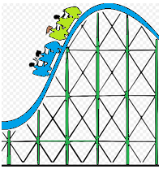

**Designing a Roller Coaster**

Using the links below investigate what makes a ‘good’ roller coaster.

<http://www.learner.org/interactives/parkphysics/coaster/>

<http://www.funderstanding.com/educators/roller-coaster-game/>

Through research, it is found that for a roller coaster to be safe whilst still being fun for patrons, the slope of any ascent must be 0.7 and the slope of any descent must be -1.8.

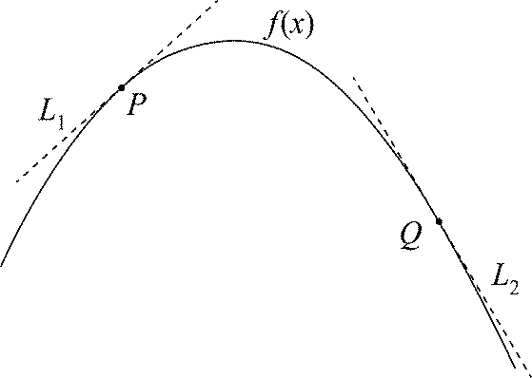

$$g(x)$$

$$h(x)$$

For the track to be smooth there can’t be abrupt changes in direction. To ensure smooth transitions between the linear segments and the parabola $g(x)$ and $h\left(x\right)$ need to be tangents to the parabola, $f(x)$ at the transition points P and Q.

To simplify the equations, you decide to place the *origin* at *P*. Furthermore, the horizontal distance between *P* and *Q* is 16 metres.

1. Find the equations of the *three segments* of track indicated below for the given domains, showing all appropriate steps of logic:
2. $g\left(x\right)=m_{1}x+k_{1}$ for $x<0$
3. $f\left(x\right)=ax^{2}+bx+c$ for $0≤x≤16$
4. $h\left(x\right)=m_{2}x+k_{2}$ for $x>16$
5. Using the website <https://www.desmos.com/calculator> plot the equations for the given domains, to check your answers. Ensure you create an account so you can save your graphs
6. After conducting some research on roller coaster specifications, your task is to design a roller coaster and specify the equations for your roller coaster track from the ***starting point*** (entrance on the left) to its ***finish point*** (exit on the right). The three segments of track from part 1 must be included in your track.
7. You must determine equations (minimum of 5) for the section on the left to join $g\left(x\right)$ and equations (minimum of 4) from $h\left(x\right)$ to the exit point, ensuring a smooth transition between points; show detailed working, equations, constraints, reasons for the choices etc. The start and exit point of your ride must be horizontal lines.

You must carefully consider:

-length and height constraints

-using a range of functions in your design

-consider different techniques for generating the functions

1. Include a discussion of any assumptions, limitations and improvements in the design of your roller coaster.

*Your answers should be written up as an investigational report. Outlined below is how your report should be formatted*

**Investigation Report**

The format of the investigation report should include:

* An outline of the problem and context
* The method required to find a solution, in terms of the mathematical model or strategy used
* The application of the mathematical model or strategy, including
* relevant data and/or information
* mathematical calculations and results, using appropriate representations
* the analysis and interpretation of results, including consideration of the reasonableness and limitations of the results
* The results and findings in the context of the problem.

How to Write an Information Report

**General Statement: (Introduction)**

**Required Vocabulary:**

* Tangent
* Differentiation
* Motion
* Gradient

**Characteristic 1:** **(Logistics)**

**Characteristic 2:** **(Calculations)**

**Characteristic 3:** **(Additional Information)**